January 17, 2026 BE SURE TO READ BOTH SIDES OF PAPER!!!!

2026 Tax Season Update (2025 Tax Year)

Tax Client(s);
Happy New Year to each of you. First thank you for your continued business. I had health issues this past year and things are going well. Those that reached out, your sentiments were much appreciated. Also, I had terrible phone service from Verizon unfortunately and changed my landline to a comcast line. I will try to make this brief as possible.
Important Notes:

- 1040 Clients managed same as in the past. Any new clients if needed will meet for a brief meeting when they drop off. Welcome new clients meetings as time permits only, but can utilize drop box also.
- I will offer small business clients from my previous work the same level of service. Not accepting new Business clients currently. I stated that in my annual letter last year.
- Yes, cost increases happen, and there are few, Average $10 increase. However, those who will notice significant price increases are those with complex returns with additional forms. See pricing breakdown included.
- Returns still include FEDERAL, STATE AND LOCAL RETURNS.
- Senior and Students still receive a discount on pricing.
- Using Secure Portal is advised for faster processing, but the drop box option remains available for those who prefer not to use technology.
Document drop off in Lock Box process:
- I ask that “ALL” customers drop off paperwork in an orderly manner. Open all envelopes and lay paperwork flat, and if possible, paperclip all pages together then place in envelope. Paper clips are optional.
- I WILL CHARGE EXTRA if I must open your envelopes and unfold paperwork!!!!!! This is a VERY TIME-CONSUMING ISSUE.
- Gather your documents at home and then drop off. Envelopes will be provided for your use. Please do not take additional envelopes for personal use.

Payment options:
- Checks accepted and can be held until refund deposit date! (Most Recommended & cost effective)
Please make Checks payable to Susan Baum Tax Service
- Be sure to include your payment check, cash, or complete ACH form to debit payment as payment will be processed upon of deposit of refund.

Thank you for your business and look forward to hearing from you soon. Wishing you and yours, health, happiness, and peace in 2026.

Sincerely,

Susan Baum

Pricing Breakdown: (Includes Federal, State and Local Tax Filings)
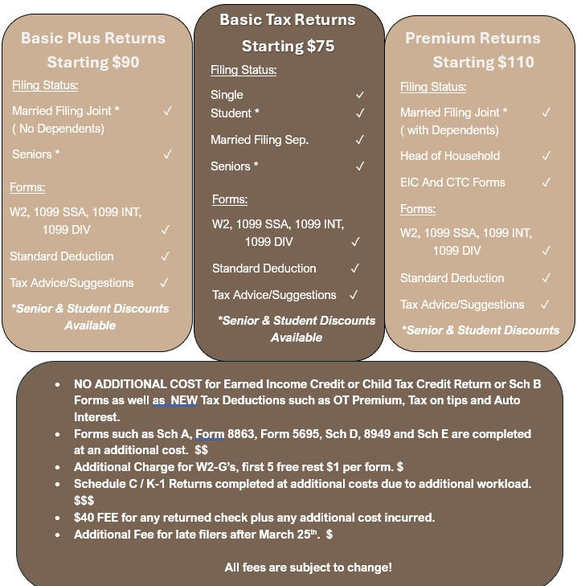
*** Property Tax Rebates $25 (Recommend having done for free at Local Reps office)
They will do the Electronic Filing for you and can get faster response on issues that may arise. Mail service stinks!
------------------------------------------------------------------------------------------------------------------------------------------------------------One Time Payment Authorization Form
Sign and complete this form to authorize Susan Baum Tax Service to make a one-time debit to your bank account. By signing this form, you give us permission to debit your account for the amount agreed upon on or after the indicated date. This is permission for a single transaction only, and does not provide authorization for any additional unrelated debits or credits to your account. Cut here and enclose with paperwork or scan to portal.
Please complete the information below:
I ____________________________ authorize Susan M Baum to charge my account indicated below for
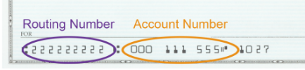
Amount agreed upon on or after date of refund deposit or specified date.
Checking/ Savings Account Banking Details:
Checking Savings
Name on Acct ____________________ Bank Name ____________________ Be sure to be accurate!!!!
Bank Routing # ____________________ Account Number ____________________
SIGNATURE DATE
SIGNATURE DATE

